Secondary Teacher Guidance
We have designed this video to be full of information and activities. As this video has been designed for all secondary school pupils, we have created differentiated tasks for each activity. Please feel free to adapt resources and activities for your class or individual pupils. We would encourage you to read through the guidance before the lesson to ensure you have everything you need. You may wish to choose activities prior to the session or using longer or shorter time frames for activities.
This lesson is aimed for an hour, however if you feel that your class would benefit from the video and activities being spread out over a few shorter sessions then please feel free to do so.
Throughout the video, Mental Health Support Team staff members explain the key information behind mental health after the activities and discussions. Therefore, all psychoeducation information will be taught. We have given some guidance for you to support any further discussions. If there are any topics that you need further information on, please visit the CFHD website: https://childrenandfamilyhealthdevon.nhs.uk/ and if you are a Mental Health Support Team school you can book in a guided reflection with your linked EMHP or Supervisor.
If at any point you notice a pupil displaying signs of distress, please feel free to give them some time out of the classroom, perhaps with a member of staff who could support them.
We encourage the class to be in a seating plan that is most comfortable for them to be able to openly discuss topics with their peers.
Resources needed:
Please ensure that every child has:
- Paper
- Pencils
- A3 paper
- Any printed resources within this guidance that you plan to use (hot cross buns, circle of control, case studies)
- Worksheet printed

Activity 1: What does mental health mean to you? (5 minutes)
Activity Choices:
- Create a word cloud. The bigger the word the more important it is or the more often you hear it. Share with the person next to you or with the class.
- Try and list or draw 3 positive, 3 negative and 3 neutral words to do with mental health. Share with the person next to you or with the class.
- Write a list, then share with the person next to you. How many things do you both have?
Remind the pupils that there are no right or wrong answers – we want to know what it means to them.
Invite whole class discussion for pupils to learn from each other. Please state to the class that there is no expectation to share if they do not wish.
The next part of the video will go into a definition of mental health so there is no need to explain this yourself.
It may be helpful to note any pupils who articulate negative ideas of mental health and perhaps have a discussion with them around this on a 1:1 basis.

Activity 2: The Hot Cross Bun (complete in pairs or small groups)
- Fill in a 'hot cross bun' diagram for a person who may either feel:
  - Anxious in social situations
  - Anxious when separating from someone
  - Or has a phobia of bees.
- Fill in a 'hot cross bun' diagram for a time you felt anxious or low.
- Adaptations for neurodiversity: some neurodiverse pupils may struggle to articulate thoughts. Instead, they could focus on another part of the model, such as physical sensations in the body or the situations this emotion may occur.
- Other difficult topics may arise during the conversation or reflection such as bullying, difficulties at home, or self-harm. We encourage you to not be dismissive of the thought process, to normalise the difficult feelings and responses that occur when experiences high levels of stress and pressure.
  - We would encourage you to follow your school’s safeguarding policy and report any concerns to your safeguarding lead.
  - Offer a check-in with the young person to allow them to process further if needed.
  - Signpost the young person to their trusted adult and other services that may be helpful:
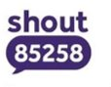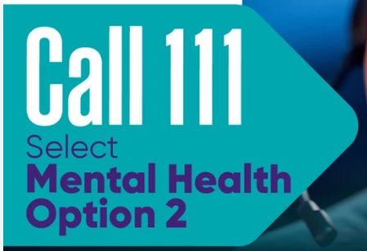
- The suggestions we give below are just possible ideas and answers, as every individual may think and act differently. Encourage discussion about individual differences and normalise that there are no wrong answers.
- The Hot Cross Bun suggestions:
 | Thoughts | Feelings | Behaviours | Body Sensations
Anxious in social situations | Are people laughing at me?  Everyone is looking at me!  I’m so embarrassed. | Worried  Embarrassed  Self-conscious | Avoid the social event  Stay quiet and avoid talking to people.  Stay with people they feel safe with. | Sweating  Hot  Butterflies in stomach.
Anxious when separating from someone | What are they doing?  Are they safe?  I can’t cope without them.  I need them. | Guilty  Shame  worried | Avoid leaving that person.  Texting them regularly to check in. | Sweating  Hot  Dry mouth
Phobia of bees | They are going to hurt me.  I can’t cope. | Scared  Panic | Flee away from the sound of bees in the distance.  Avoid eating ice-creams in the summer just in case. | Breathing fast  Heart beating fast  Legs feel weak and wobbly

Activity 3: Signs of Mental Health Concern
Self-reflection task using the sentences to identify individual signs:
When I start to feel overwhelmed, I notice that I _______
My friend starts to ______ when they being feeling overwhelmed.
When I start to feel down/sad, I notice that I _______
My friend starts to ______ when they being feeling down/sad.
When I start to feel worried/scared, I notice that I _______
My friend starts to ______ when they being feeling worried/scared.
- Remind pupils that everyone is different. We all will experience and show emotions differently.
- This activity can be extended by changing the emotion (E.g. Anger). Or extend the conversation by ordering the list of signs from how early they begin. For example, when I get angry the first sign I get is feeling warm, then it builds to fist clenching and ends with me shouting.
- Remind the pupils that if they have never taken the time to notice or reflect on how their body and mind reacts to different emotions, then they might not know their signs. It would be beneficial to set as a home task and bring back to discuss.
- Other difficult topics may arise during the conversation or reflection such as self-harm, destructive behaviours or behaviours of risk. We encourage you to not be dismissive of the thought process, to normalise the difficult feelings and responses that occur when experiences high levels of stress and pressure.
  - We would encourage you to follow your school’s safeguarding policy and report any concerns to your safeguarding lead.
  - Offer a check-in with the young person to allow them to process further if needed.
  - Signpost the young person to their trusted adult and other services that may be helpful:

Activity 3: Signs of Mental Health Concern
Self-reflection task using the questions below:
What did that person do?
Why did it make a positive impact on you?
What was the immediate, short-term impact of this person’s actions?
Did this moment of kindness or support last longer? How?
Is this something you can replicate for someone else?
- Remind pupils that it does not need to be a big positive event, nor does it have to be recent.
- To support pupils who are struggling to identify positive events, you could rephrase to an event that they have done to positively impact someone.
- It could be helpful for you to give examples of how you have positively impacted someone.
- Some young people may have ‘black and white thinking’ pattern when it comes to reflecting and finding positives. This term means that unless the event was 100% positive then it does not count. It would be helpful to support the young person to talk through the different parts of the event.
Activity 4: What can help manage Mental Health
As the class continue these discussions, create a mind map or display to document all the ideas suggested on the video and suggested from the class.
Keep the display/poster in the classroom and refer to it next week to see if anyone managed to do any of the ideas.
- We would recommend spending a few minutes reflecting each week, adding new ideas and discussing as a class.
- This ensures that mental health and wellbeing is being continually mentioned whilst giving young people time to process and apply strategies to improve their mental health.
Activity 5: The 10 a day
- During this part of the video the MHST staff take time to explain the different parts of the 10 a day.
- If you would like to extend the young people, you could ask them:
  - What about the 10 a day works for you?
  - What about the 10 a day do you forget about?
  - What would you like to work on within the 10 a day?
Activity 5: Circle of Connection
- When showing the circle of connection tool, it is important to share that everyone’s circle of connection is different. Some people will find connecting with others easy and others hard. Some people will have found ‘their people’ already and other’s may need to keep searching.
- It is also important to state that these people and circles move and change over time. It is a useful tool to check-in if we are feeling disconnected, lonely, or even bored.
- To push the conversation further: How can you build more connections?
(Joining clubs you enjoy, talking to people, have open body language, listening to people)
- This discussion may be difficult for some young people. We encourage you to normalise the difficult feelings that occur when identifying difficult emotions and experiences such as previous bullying, loneliness, and not being accepted.
  - We would encourage you to follow your school’s safeguarding policy and report any concerns to your safeguarding lead.
  - Offer a check-in with the young person to allow them to process further if needed.
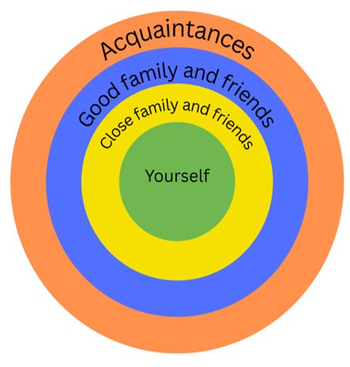

Activity 6: Case studies
- Give out case studies (Below)
- Here are some suggestions of answers. However, there are many possibilities that could work.
Elle | Be around people, try to do things that matter to her, take small steps to making her day better, begin making a routine each day that includes things she enjoys and things that are important to do.  Friend – say you’ve noticed that they’re not themselves at the moment and offer to listen, offer to do an activity together, suggest seeking help
Leila | Reflect on the changes that have happened over the last few months, are there any changes that haven’t been properly managed? Speak to teachers and tutor and raise worries of struggling to concentrate. Ask for help in class.  Friend – offer to listen, complete homework together, suggest seeking help, offer a distraction activity each week.
Tao | Reflect on where these thoughts and feelings have come from. Increasing comparison of others can negative impact our mental health. Are they spending too much time on social media or activity comparing themselves to others?  Question these thoughts and start doing activities to increase their confidence and wellbeing. Focus on the effort not the result.  Friend – reach out for support, offer to do something together, suggest seeking help.
Charlie | Speak to teachers and tutor and raise worries of struggling to concentrate. Reflect on sleeping routine and pattern – is there any way to improve this?  Friend – talk through what he is worried about, offer to support him in classroom situation, suggest seeking help.
- If young people share the impact of ‘Trauma dumping’ from friends then support the discussion around ‘how much should we been supporting our friends?’ ‘What do we do if their mental health is negatively impacting ourselves?’
  - Remember you are their friend and not their mental health practitioner or therapist.
  - Encourage young people to direct their friends to speak to a trusted adult.
  - Signpost the young person to their trusted adult and other services that may be helpful:

Activity 6: Worksheet
- Print out the worksheet attached.
- The worksheet offers an overview of the key bits of information and signposting.
- We encourage the young people to add any other important bits of information they would like to remember. We then would like them to reflect on what helps them when they are struggling. They can use any ideas from the discussions today.
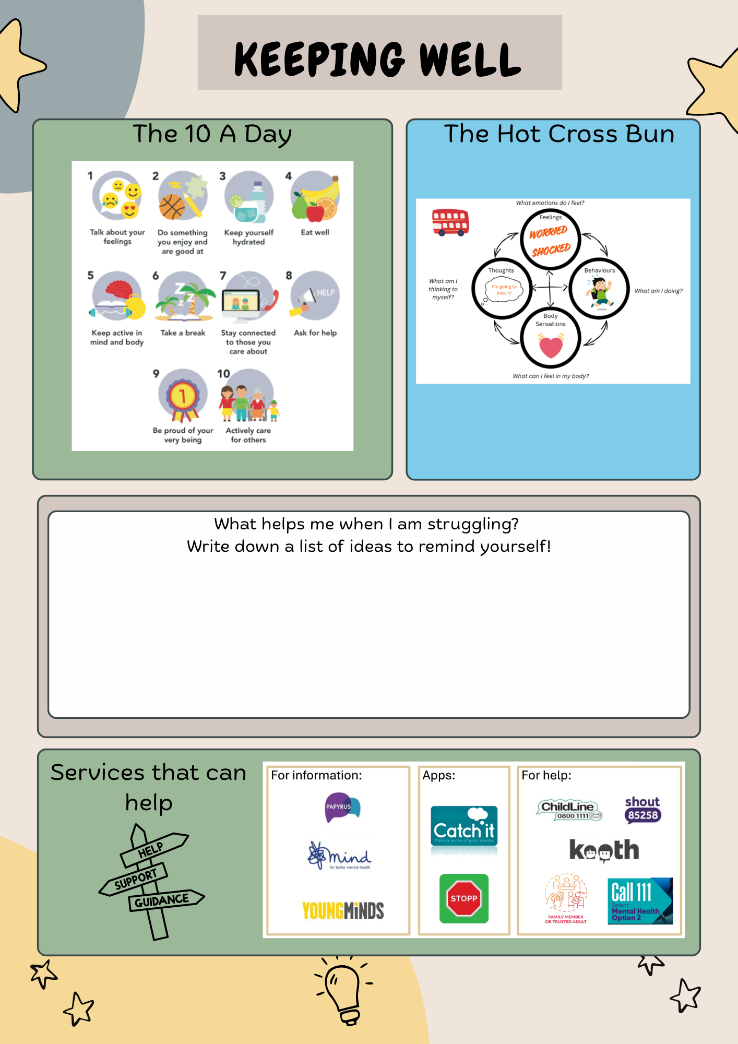

Thank you for using this resource. If you have any questions or feedback, please contact us at cfhd.mhstadmin@nhs.net

