https://www.mencap.org.uk/advice-and-support/health/dont-miss-out



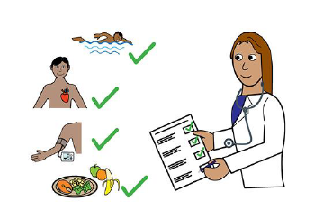







|  |
| --- |
| **Learning Disability**  **Annual Health Check for ages 14 and over**  **Information for families and carers** |

**For further assistance or to receive this information in a different format, please contact the department which created this leaflet**

CFHD LD/Directorate/TSDFT/07.22/Review date 07.24

**People with Learning Disabilities can die younger than others**

**The Learning Disability mortality review programme (LeDeR) looks at why.**

**information on the post-14 Annual Health check you can contact your GP, the following websites have further information:**

[](https://www.nhs.uk/conditions/learning-disabilities/annual-health-checks/)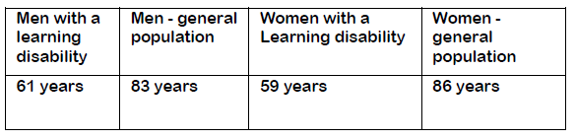

|  |  |  |
| --- | --- | --- |
|  |  |  |
|  |  |  |

Ask for a free Learning Disability

Annual Health Check at your local GP surgery

For more information on the post-14 Annual Health check you can contact your GP, the following websites have further information:

[**www.nhs.uk/conditions/learning-disabilities/annual-health-checks/**](http://www.nhs.uk/conditions/learning-disabilities/annual-health-checks/)

[**https://www.mencap.org.uk/advice-and-support/health/dontmissout**](https://www.mencap.org.uk/advice-and-support/health/dontmissout)



The GP will give you a copy of the Health Action Plan.

It tells you what you need to do.

If you need more appointments these will be booked.

Your GP surgery will invite you once a year for Annual health check.







**If you are scared of needles, talk to the GP.**

**You may be offered the nasal spray flu vaccine instead of an injection.**

**There is more information on this website:**

[**www.gov.uk/government/publications/flu-vaccinations-for-people-with-learning-disabilities/flu-vaccinations-supporting-people-with-learning-disabilities**](http://www.gov.uk/government/publications/flu-vaccinations-for-people-with-learning-disabilities/flu-vaccinations-supporting-people-with-learning-disabilities)





The Annual Health Check will include;

✓ Blood pressure check

✓ Weight / Height / BMI calculation

✓ Check your ears

✓ Ask when you saw the dentist and had an eye test.

✓ Discuss Sexual Health and relationships

✓ Review of medication – this may include prescription for new medication

✓ Referrals to other services (if needed)

✓ Talk about vaccines.

✓ Blood tests (if needed)

The Annual Health Check reviews your health.

This should include a physical examination.

It should last for a minimum of 30 minutes.

You may see more than one professional to complete the check.





When you are 16 years old or older

You will be supported to make more of your own choices and decisions about your health plans.

**You must be on your GP’s Learning Disability**

Register to have an Annual Health Check.

The GP Learning Disability register is a list of names.

It tells the GP who to invite.

You can ask at your GP surgery if you are on the register.



**Annual Health Checks are offered to people with learning disabilities aged 14 and over.**

Annual Health Checks are completed at your GP surgery.

It is a way to ensure health issues are diagnosed and addressed.

They support health and wellbeing and help to reduce hospital admissions.

