Sensory Differences Workbook
Contents

Sensory Differences Handouts Available
Making a Sensory Plan
Sensory Difference Notebook

Sensory Differences Handouts

There are a number of additional sensory handouts available for you to download attached to this workshop. Alternatively, let us know and we can print them off and send them to you.

- Sensory differences plan
- Our own sensory preferences activities
- Environmental sensory strategies
- Proprioception activity ideas for home and school
- Sensory strategies for dressing
- Sensory strategies for toileting
- Sensory strategies for washing
- Sensory strategies for feeding
- Interoception advice sheet
- Sensory Equipment List
- Further information/ website recommendations

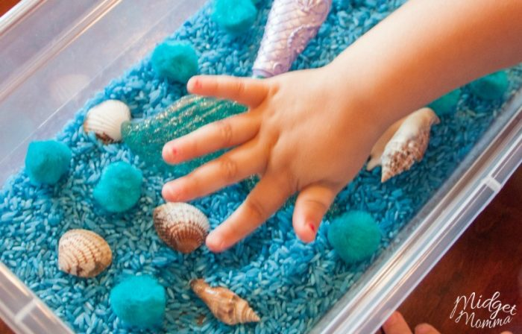

Making a Sensory Plan

One of the main aims of this workshop is for you to create a plan with your child using sensory strategies to support their engagement with a challenging activity. Please ask your child what he/she would like to do able to do differently; it is more likely to succeed this way.

There is a Sensory Difference Plan ready for you to complete amongst the documents attached that you can use for yourself and share with others such as school once you have completed the workshop. A copy of the presentation slides to supplement your notes is also available if you would like it.

Please use the notebook on the next page to write your own ideas down throughout the presentation and when prompted by the presenter.

SENSORY WORKSHOP NOTEBOOK
Use this notebook during the workshop to write down your thoughts and ideas specific to your child.

Write down the sensory challenge you/ your child would like to work on:

Listen to the workshop but feel free to pause it at any time. Remember there is a copy of the slides to help you as well if you need it.

Write down if you have seen your child show any preferences relating to any of the senses and if they need more sensory information (big teacup) or less sensory information (little teacup). Also note down any sensory strategies within the boxes which you feel will be helpful to try with your child.

VISION | HEARING
TASTE | SMELL
TOUCH | PROPRIOCEPTION
VESTIBULAR | INTEROCEPTION

ENVIRONMENT

What environments does your child enjoy?

What environments do they find difficult?

What could you do to modify the environment?

SENSORY STRATEGIES TO TRY…..

Write down again the daily activity you would like to focus on?

Write down the sensory strategies you are going to try to help manage this
activity:

BEFORE

DURING

AFTER

SENSORY STRATEGIES TO TRY…..

Write down the daily activity you would like to focus on?

Write down the sensory strategies you are going to try to help manage this activity:

BEFORE

DURING

AFTER

SENSORY STRATEGIES TO TRY…..

Write down the daily activity you would like to focus on

Write down the sensory strategies you are going to try to help manage this activity:

BEFORE

DURING

AFTER

OVERVIEW OF PLAN AND STRATEGIES

THE CHALLENGE | ENVIRONMENTAL | SENSORY STRATEGIES
THE CHALLENGE
E CHALLENGEE CHALLENG

You can now share the plan above with everyone who cares/ works with your child or please use the separate document ‘Sensory Differences Plan.’

