Sensory Equipment List
All the equipment can be found on the internet using search term on the left. It is recommended that all these pieces of equipment are used with adult supervision.
Equipment | Picture | Website
Move ‘n’ sit cushion/ Wobble cushion | 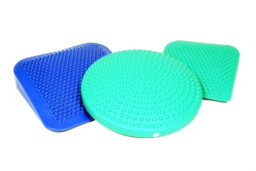 | https://www.sensorydirect.com/2017/09/benefits-wedge-wobble-cushions/  https://www.amazon.co.uk/  https://www.nrshealthcare.co.uk/
Ear Defenders | 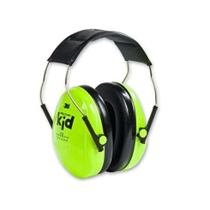 | https://www.decathlon.co.uk/  https://www.amazon.co.uk/  https://www.sensorydirect.com/catalogsearch/result/?q=ear+defenders
Chewy Tubes/ Chewbuddy | 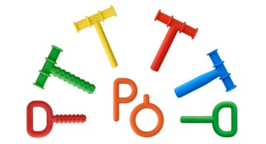 | https://www.sensorydirect.com/  https://www.amazon.co.uk/
Fidget toys | 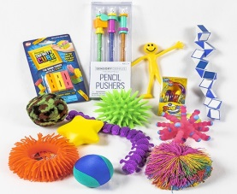 | https://www.amazon.co.uk/  https://www.sensorytoywarehouse.com/
Therapy ball/ yoga ball/ peanut ball | 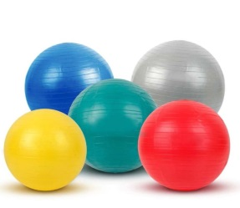 | https://www.amazon.co.uk/  https://www.sensorydirect.com/anti-burst-therapy-ball.html?gclid=EAIaIQobChMIo5nXgIz-6AIVRuztCh1JZQkkEAQYASABEgJPAPD_BwE#137=93

Equipment providers:
- Suppliers of clothing for children that may find it difficult to tolerate certain textures.
www.sensorysmart.co.uk
- Suppliers of toys, clothing and a variety of equipment to support individual sensory preferences.
www.sensorydirect.com or www.rompa.com

