Our Own Sensory Differences Activities

It’s important to be aware of your own sensory differences; these are likely to differ from those around you. You will have your own coping strategies, that you may not even realise you use, to help you manage in different situations.
Have a think about what you do and note them below, using the suggested activities to guide you.

Task 1: Let’s Think About Ourselves
- What is the first thing you do to wake yourself up in the morning?
- What does your clothing feel like?
- Is the chair comfortable?
- Can you hear anything?
- What can you smell? Taste?
- Are you worried about anything?
- Are you unwell or in pain?
- Did you have a good night’s sleep?

Understanding your own sensory differences will help you to be able to support your child. It is important to record your child’s likes and dislikes.

Task 2: Peeling an orange
Equipment needed:
- An orange

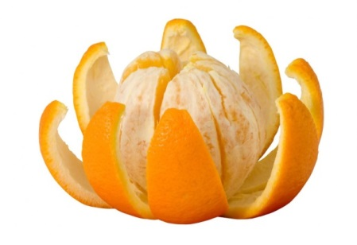
Next time you eat or peel an orange, think about how you know it’s an orange.
- How does it feel?
- What is the texture or shape?
- Does it smell?
- What sensory systems might you use to discriminate its properties letting you know that it’s an orange not a banana?

Thoughts:
- Can your child peel an orange?
- Can they find something using touch alone?
- Do they need to use their vision too?
- What are their fine motor skills like?

Task 3: Touching your nose with your eyes closed

Equipment needed:
- Something to film with or another person
- A solid wall free from furniture or pictures.

Activity
You will need someone to either film you or watch you and feedback.
Stand and place your feet together. Place your arms out to the side fully extended so you are making a T shape. Close your eyes. Now bend your elbow and touch the tip of your nose with the tip of your finger.
Now either watch the video of yourself or ask the person observing you to tell you:
- Did you touch the tip of your finger to your nose?
- Did you touch another part of your finger and then adjust to use the tip?
- Did you miss altogether?
- Did you wobble or sway when your eyes were closed?
Questions
If you missed your nose with the tip of your finger this could mean you need more proprioception to know where your body is in space. If you were able to adjust your position to touch your nose on the second go, you probably used your touch system to feedback.
If you wobbled or swayed, what could that mean about your awareness of where your body is in space?
Now find a solid wall that is free from clutter. Place the palms of your hands against the wall and push really, really hard using your whole body. Try to push the wall over.
Repeat the activity: Feet together, standing up. Try to touch your finger to your nose with your eyes closed.
- Were you more accurate?
- Did you wobble/ sway more or less than before?
- How do you feel?
Hopefully you found it easier and felt more body awareness after pushing the wall and engaging your muscles in some strong resistance work (proprioceptive activities).

We hope you enjoyed trying these activities it really makes you aware of your environment, your own body and how you respond to it.

